**Assignment 1 –Import Acadgild VM into Oracle virtual box by**

**following the document shared in the dashboard.**

Please find the below snapshots,

**Step1**:Virtual box need to be installed by clicking below link,

Link: https://drive.google.com/file/d/0Bxr27gVaXO5sRXdxQVpEUmhCZ3c/view?usp=sharing

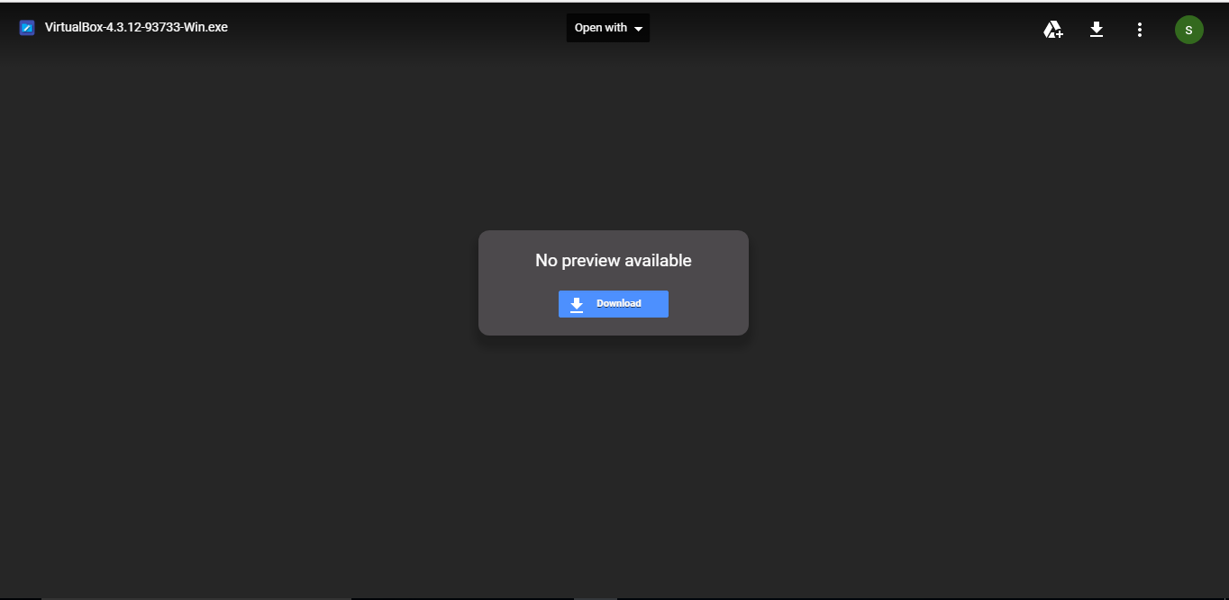

**Step2**: After installing Oracle virtual machine we need to follow below steps,

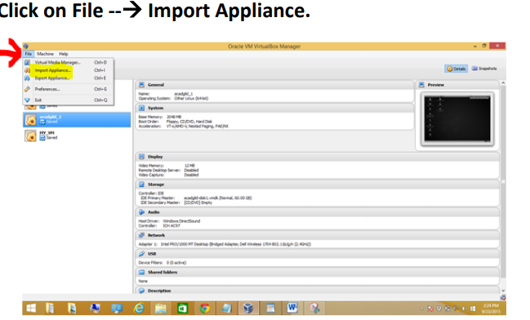

Step3:Click on folder option to select the Acadgild Vm ,

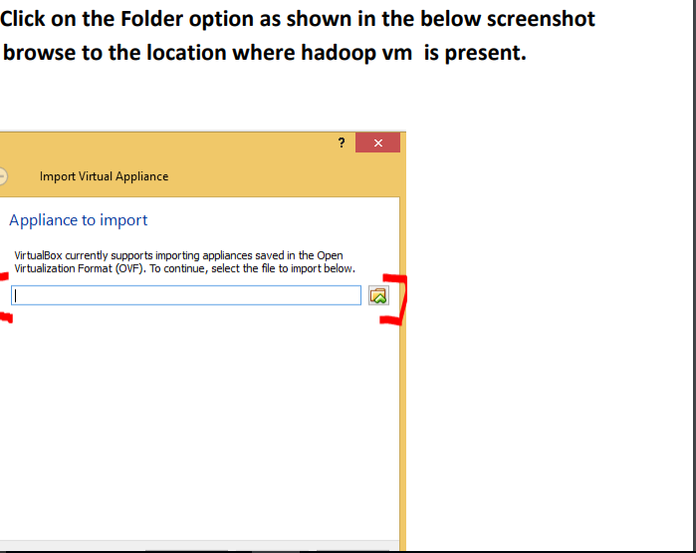

Step4:once all the other process done then we can find the acadgild has been imported in the oracle VM,

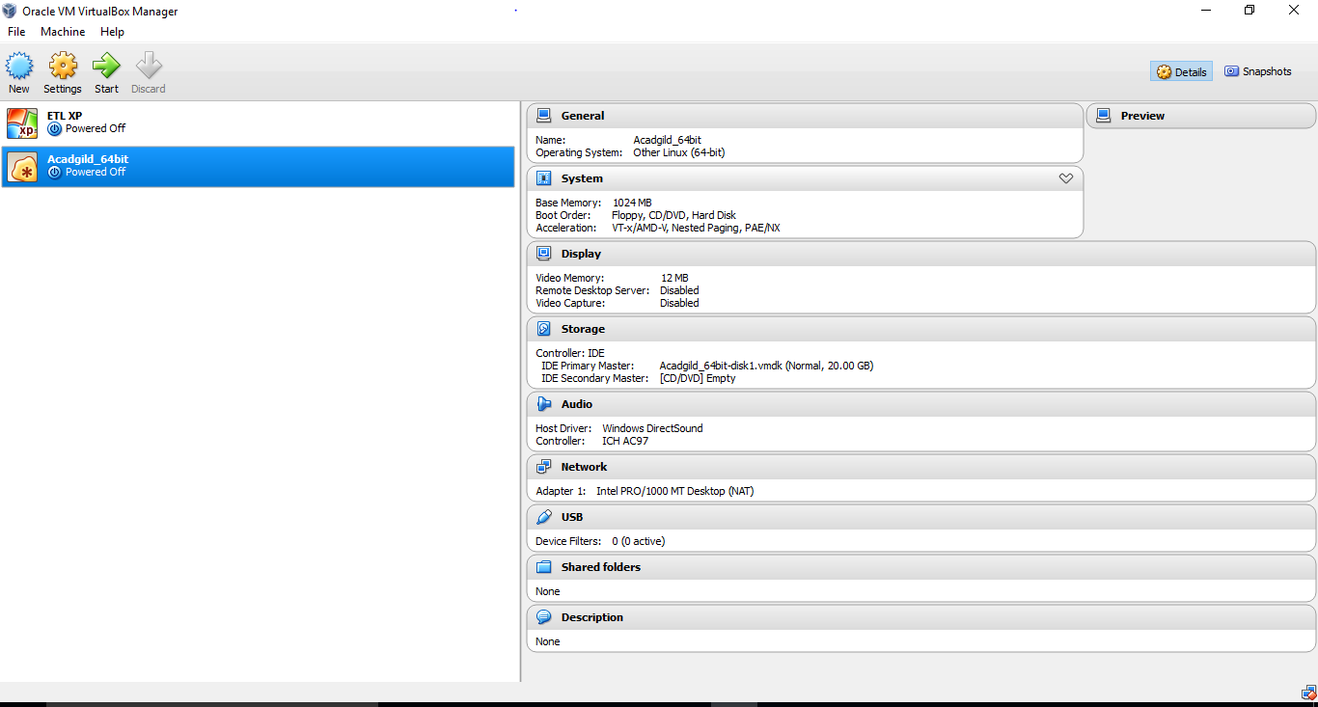

Step5:Click on Acadgild_64bit VM will get the login page,

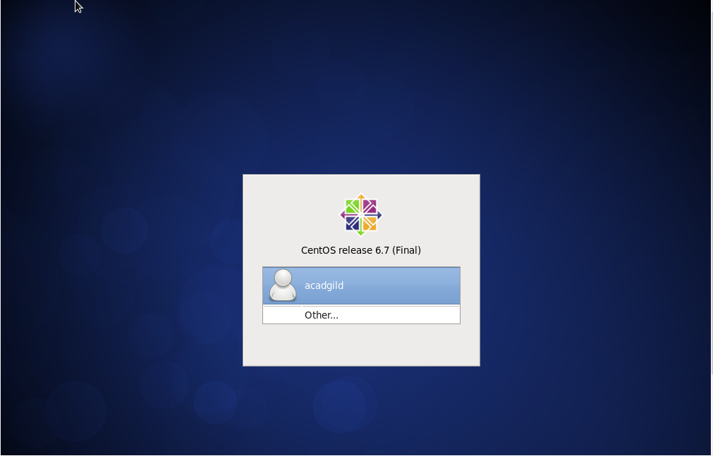

Step6:Click on Acadgild and give the credentianls ,

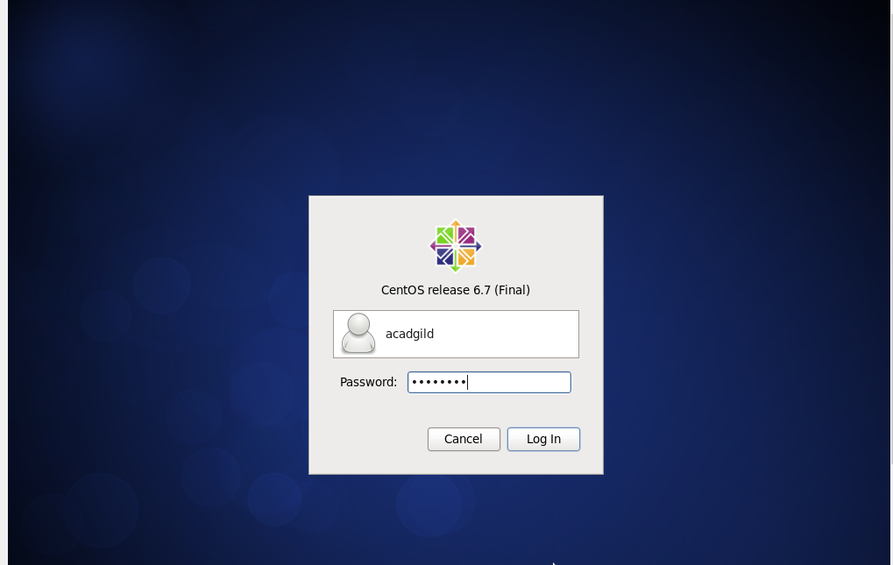

Step7:We can find the acadgild VM window with their respective folders.

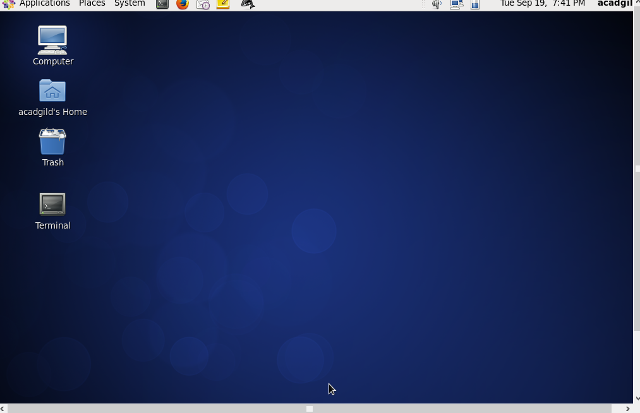

Step8:Once if we open the Acadgild’s VM we can find the terminal on the desktop of VM if we double click find it below,

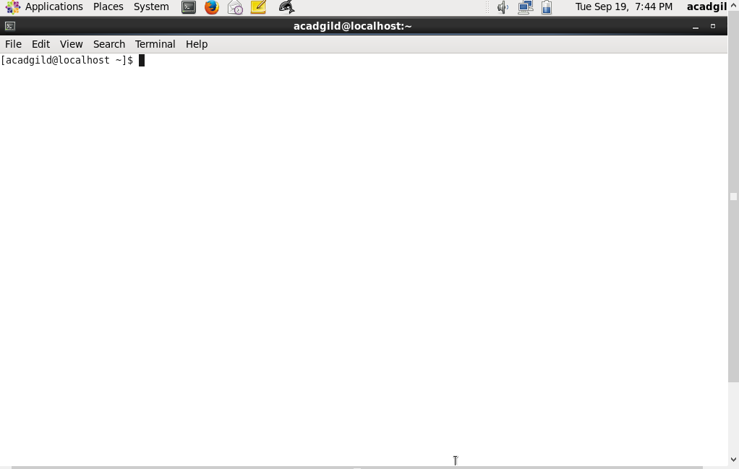

********************************END************************************************